

**MPhil in Machine Learning and, Machine Intelligence 2018-2019**

**Module Coursework Feedback**

Module Title: Robotics

Module Code: 4M20

Candidate Number: F606F

Coursework Number: 2

***I confirm that this piece of work is my own unaided effort and adheres to the Department of Engineering’s guidelines on plagiarism.***

Date Marked: Click here to enter a date. Marker's Name(s): Click here to enter text.

**Marker's Comments:**

**This piece of work has been completed to the following standard** *(please circle as appropriate)*:

|  |  |  |  |  |  |  |  |  |  |
| --- | --- | --- | --- | --- | --- | --- | --- | --- | --- |
|  | **Distinction** | | | **Pass** | | | **Fail (C+ - marginal fail)** | | |
| **Overall assessment**  **(circle grade)** | **Outstanding** | **A+** | **A** | **A-** | **B+** | **B** | **C+** | **C** | **Unsatisfactory** |
| **Guideline mark (%)** | 90-100 | 80-89 | 75-79 | 70-74 | 65-69 | 60-64 | **55-59** | **50-54** | **0-49** |
| **Penalties** | **10% of mark for each day, or part day, late (Sunday excluded).** | | | | | | | | |

The assignment grades are given **for information only**; results are provisional and are subject to confirmation at the Final Examiners Meeting and by the Department of Engineering Degree Committee.

**Question 1**

Given that the Arduino control scales the possible achievable angles of the motor from 0 to 1, a function that can transform the angle input into the unit output is needed, which allows us to control the motor angle accurately and precisely.

It is found that the motor has around ${180}^{°}$ accessible angle range, the outer ring which connects the arm with the motor output is adjusted to achieve the designed angle trajectories.

$$θ_{1}$$

$$θ_{2}$$

$$θ_{3}$$

$$L_{1}$$

$$0$$

$$1$$

$$L_{2}$$

$$L_{0}$$

$$L_{3}$$

$$L_{4}$$

$$L_{5}$$

$$2$$

$$3$$

$$4$$

Figure : The robot architecture.

Consider the material provided, the length of arm is $0.14m$ and the length of the foot is $0.2m$. Again, the inverse kinematic is used to compute the joint angles from rear and front feet locations.

When we want to move the rear foot, we set the front foot as the reference point $\left(0,0\right)$ so that the range of x is denoted by $\left(0.2,0.28\right)$ m.

$$\left(\begin{matrix}θ_{1} \\ θ_{2} \\ θ_{3}\end{matrix}\right)=\left(\begin{matrix}π-θ_{2}-θ_{3} \\ cos^{-1}\left(\frac{x^{2}+y^{2}}{2L^{2}}-1\right) \\ sin^{-1}\left(\frac{x}{L}+\frac{s_{2}}{1+c_{2}}\frac{y}{L}\right)\end{matrix}\right)$$

, where $θ_{i}$ the joint angle between arms $i$ and $i+1$ and $L$ the length of the arm.

When moving the front foot, the rear foot is set as the reference point $\left(0,0\right)$, so the range of x is $\left(-0.28,-0.2\right)m$.

$$\left(\begin{matrix}θ_{1} \\ θ_{2} \\ θ_{3}\end{matrix}\right)=\left(\begin{matrix}sin^{-1}\frac{1}{2}\left(\frac{-x}{L}+\frac{s_{2}}{1+c_{2}}\frac{y}{L}\right) \\ cos^{-1}\left(\frac{x^{2}+y^{2}}{2L^{2}}-1\right) \\ π-θ_{1}-θ_{2}\end{matrix}\right)$$

The maximum separation between the front and rear feet is $0.28m$, this corresponds to the angles $\left(θ_{1},θ_{2},θ_{3}\right)=\left({45.6}^{°},{88.8}^{°},{45.6}^{°}\right)$, and the minimum separation is $0.2m$ which corresponds to the angles $\left(θ_{1},θ_{2},θ_{3}\right)=\left({90}^{°},0^{°},{90}^{°}\right)$. Ideally, we also wish to raise the rear foot forwards by $(0.28-0.2)/2 = 0.04m$ and upwards by $0.05m$ which is the height of the stair or the obstacle from the maximum separation pose. Similarly, for the front foot, what differs is it is raised from the minimum separation pose. Their corresponding angles are $\left({49.3}^{°},{57.8}^{°},{72.3}^{°}\right)$ and $\left({72.3}^{°},{57.8}^{°},{49.3}^{°}\right)$.

So, we calibrate the motors in the way that the motor 1 has the angle range $\left(θ_{1,min},θ_{1,max}\right)=\left(-{147}^{°},-5^{°}\right)$, the motor 2 has angle range of $\left(-{70}^{°},{90}^{°}\right)$ and the motor 3 has the range of $\left(-{50}^{°},{125}^{°}\right)$. And using the equation below, the angle input for each motor will be converted to the unit output,

$$Unit_{i}=\frac{θ_{i}-θ_{i,min}}{θ_{i,max}-θ_{i,min}}$$

, where $θ_{i}$ the input angle of motor $i$, $θ_{i,min}$ the minimum calibrated angle of motor $i$, $θ_{i,max}$ the maximum calibrated angle of motor $i$ and $Unit_{i}$ the output unit for the motor $i$ readable by the Arduino system.

The following matlab functions are then written to compute the units automatically,

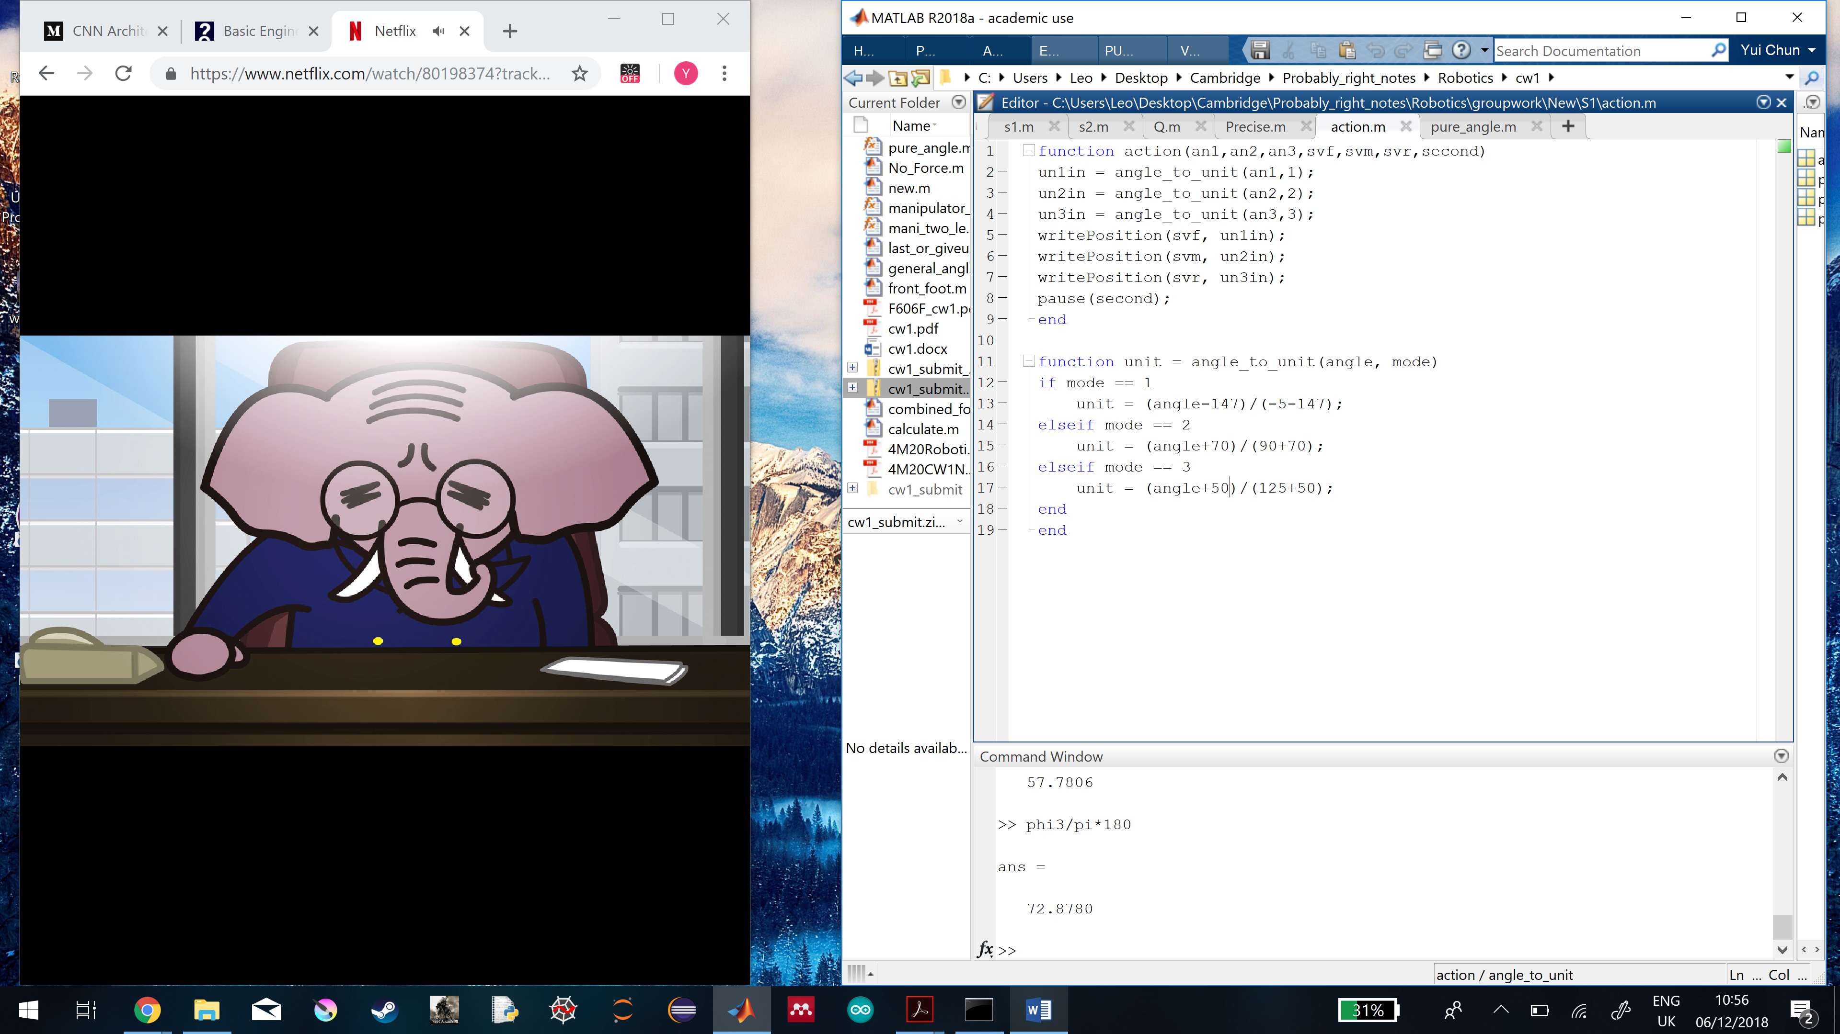

And execute the command to drive the motor via the Arduino system,



However, this approach of using the inverse kinematics to control the motors is not working, since the influence of gravity and the maximum torque output of the motor are not taken into account. The motors cannot reach the angles as expected.

To explain this, the theory of moment of inertia is used. Assume that the total weight lifted by a motor $i$ is the sum of the weights of other motors only (excluding the arm weights), each motor is approximated as a cube and has the moment of inertia of the cube.

Therefore, the rotational inertia for the motor 1 is given by,

$$I_{1}=M\left(\frac{1}{3}s^{2}+L^{2}+2{\left(Lcos\frac{θ_{2}}{2}\right)}^{2}\right)$$

By considering the geometry, the minimum torque acting by the weight depends on the joint angles,

$$τ_{1,min}=MgL\left(sinθ_{1}+2sin\left(θ_{1}+\frac{θ_{2}}{2}\right)cos\frac{θ_{2}}{2}\right)$$

Similarly, for the motor 2, the rotation inertia and the minimum torque are given by,

$$I_{2}=M\left(\frac{1}{3}s^{2}+2L^{2}\right)$$

$$τ_{2,min}=MgL\left(sinθ_{1}+sinθ_{3}\right)$$

For the motor 3, the rotation inertia and the minimum torque are given by,

$$I_{3}=M\left(\frac{1}{3}s^{2}+L^{2}+2{\left(Lcos\frac{θ_{2}}{2}\right)}^{2}\right)$$

$$τ_{3,min}=MgL\left(sinθ_{3}+2sin\left(θ_{3}+\frac{θ_{2}}{2}\right)cos\frac{θ_{2}}{2}\right)$$

The angular acceleration of the motor $i$ is given by,

$$α_{i}=\frac{τ_{i}-τ_{i,min}}{I_{i}}$$

, where $τ_{i}$ the output torque of the motor.

Whether the motor can drive the weights to the instructed angle and execute the action depends on its pose for its previous action. As it will affect the angular acceleration, if $α= 0$, the motor cannot lift at that angle but can only stay at that angle. This explains why sometimes the motors cannot execute certain actions under certain poses.

Especially when the motherboard is attached on the 3rd arm, the motor 1 cannot lift the rear foot as expected with any pose. So, a prepared pose is needed to lift the rear foot as expected.

Figure : It shows how the robot needs a prepared pose to execute another move.

Since the feet are not modified, there is another problem caused by the screws which make the feet not flat and induce motion instability.

Moreover, the robot is constructed with non-identical arms which are not in the same length. Thus, the inverse kinematics equations with equal arm length assumption cannot estimate the accurate joint angles.

The wires connected to the motherboard on the robot provide extra inertia to the robot. If the wires are from the travelling direction of the robot, the robot can move forwards more easily. But if the wires are opposite the travelling direction, they pull the robot backwards, the robot moves forwards more slowly.

Due to the influence of weight, the non-identical arm lengths, the wires and the non-flat feet, the robot was found to oscillate a lot during the execution.

To overcome these problems, we have developed a Graphical User Interface with matlab to fine tune the executed angles. But we have tried not to control in a small step since more steps mean more vibrations and uncertainties are induced. And we have tried to strategize the motion with higher tolerance of uncertainties.

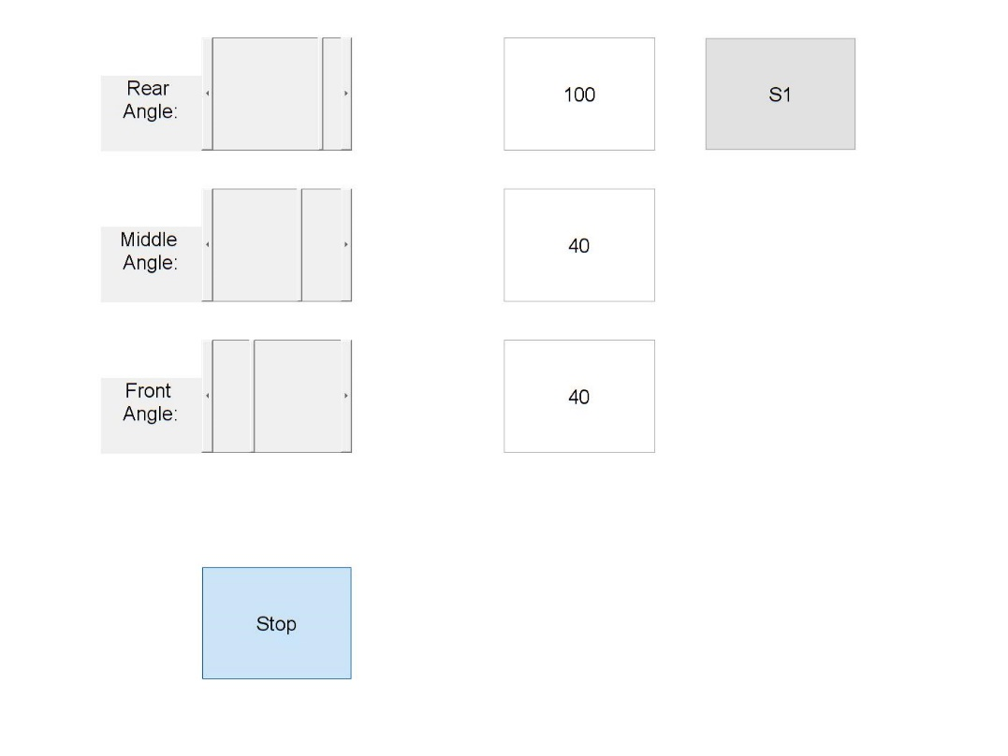

Figure : Graphical User Interface (GUI) which can control the joint angles of the robot.

For the locomotion Problem 1, our strategy is that the robot first walks towards the stair, when it is in front of the stair, it performs a backflip motion. The arm then extends to pass the goal.

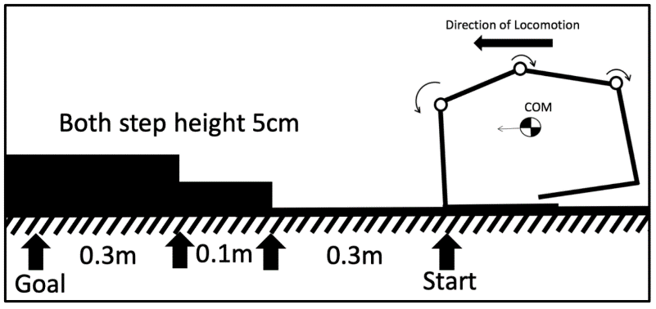

Figure : Locomotion Problem 1.

1

2

3

4

Staircase

Walking towards the staircase

Staircase

Stop

Staircase

Raise rear arm

Staircase

Backflip

Goal

Figure : Strategy for locomotion problem 1 applied to reach the goal.

For the locomotion Problem 2, our strategy is that the robot first walks towards the obstacle. Then it uses its front arm to grab the obstacle and pulls itself up to the obstacle. The rear foot kicks the obstacle and the robot crosses the obstacle. Finally, it walks towards the goal to finish the task.

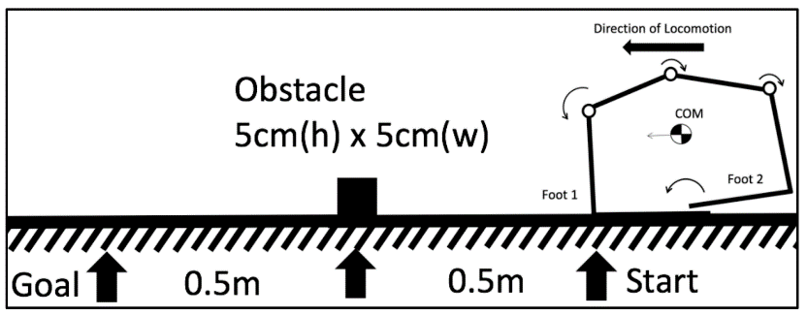

Figure : Locomotion Problem 2.

1

2

4

Walk towards the obstacle

Stop

3

Raise front arm

Grab the obstacle and pull

5

6

8

Land the obstacle

Hit the ground and lift up

Kick the obstacle and overcome

Walk towards the goal

7

Figure : Strategy for Locomotion Problem 2 applied to reach the goal.

**Question 2 (run s1.m and s2.m)**

I choose to change my strategy that replicates the trajectory of the last group since it can be simulated directly by the kinematic method without considering too much about the complex dynamic control.

In my simulation, the joint angles’ trajectories for 1st locomotion problem are,

When walking to the front of the staircase,

$$5\left[\left(\begin{matrix}{34.8}^{°} \\ {110.3}^{°} \\ {34.8}^{°}\end{matrix}\right)→\left(\begin{matrix}{8.8}^{°} \\ {120.3}^{°} \\ {50.9}^{°}\end{matrix}\right)→\left(\begin{matrix}{20.9}^{°} \\ {138.2}^{°} \\ {20.9}^{°}\end{matrix}\right)→\left(\begin{matrix}{50.9}^{°} \\ {120.3}^{°} \\ {8.8}^{°}\end{matrix}\right)\right]→\left(\begin{matrix}{34.8}^{°} \\ {110.3}^{°} \\ {34.8}^{°}\end{matrix}\right)$$

When climbing over stairs,

$$\left[\left(\begin{matrix}{34.8}^{°} \\ {110.3}^{°} \\ {34.8}^{°}\end{matrix}\right)→\left(\begin{matrix}{8.8}^{°} \\ {120.3}^{°} \\ {50.9}^{°}\end{matrix}\right)→\left(\begin{matrix}{20.9}^{°} \\ {138.2}^{°} \\ {20.9}^{°}\end{matrix}\right)\right]→2\left[\left(\begin{matrix}{50.1}^{°} \\ {132.9}^{°} \\ -3.0\end{matrix}\right)→\left(\begin{matrix}{61.5}^{°} \\ {85.2}^{°} \\ {33.4}^{°}\end{matrix}\right)→\left(\begin{matrix}{45.6}^{°} \\ {88.8}^{°} \\ {45.6}^{°}\end{matrix}\right)→\left(\begin{matrix}{20.9}^{°} \\ {138.2}^{°} \\ {20.9}^{°}\end{matrix}\right)\right]$$

Lastly, walking towards the goal,

$$5\left[\left(\begin{matrix}{20.9}^{°} \\ {138.2}^{°} \\ {20.9}^{°}\end{matrix}\right)→\left(\begin{matrix}{50.5}^{°} \\ {122.5}^{°} \\ {6.9}^{°}\end{matrix}\right)→\left(\begin{matrix}{32.4}^{°} \\ {115.2}^{°} \\ {32.4}^{°}\end{matrix}\right)→\left(\begin{matrix}{6.9}^{°} \\ {122.5}^{°} \\ {50.5}^{°}\end{matrix}\right)\right]→\left[\left(\begin{matrix}{20.9}^{°} \\ {138.2}^{°} \\ {20.9}^{°}\end{matrix}\right)→\left(\begin{matrix}{50.5}^{°} \\ {122.5}^{°} \\ {6.9}^{°}\end{matrix}\right)→\left(\begin{matrix}{32.4}^{°} \\ {115.2}^{°} \\ {32.4}^{°}\end{matrix}\right)\right]$$

The predicted joint angles’ trajectories for 2nd locomotion problem is,

When walking to the front of the obstacle,

$$10\left[\left(\begin{matrix}{32.4}^{°} \\ {115.2}^{°} \\ {32.4}^{°}\end{matrix}\right)→\left(\begin{matrix}{6.9}^{°} \\ {122.5}^{°} \\ {50.5}^{°}\end{matrix}\right)→\left(\begin{matrix}{20.9}^{°} \\ {138.2}^{°} \\ {20.9}^{°}\end{matrix}\right)→\left(\begin{matrix}{50.5}^{°} \\ {122.5}^{°} \\ {6.9}^{°}\end{matrix}\right)\right]→\left(\begin{matrix}{32.4}^{°} \\ {115.2}^{°} \\ {32.4}^{°}\end{matrix}\right)$$

When climbing over the obstacle,

$$\left[\left(\begin{matrix}{6.9}^{°} \\ {122.5}^{°} \\ {50.5}^{°}\end{matrix}\right)→\left(\begin{matrix}{20.9}^{°} \\ {138.2}^{°} \\ {20.9}^{°}\end{matrix}\right)\right]→\left[\left(\begin{matrix}{50.1}^{°} \\ {132.9}^{°} \\ -{3.0}^{°}\end{matrix}\right)→\left(\begin{matrix}{61.5}^{°} \\ {85.2}^{°} \\ {33.4}^{°}\end{matrix}\right)→\left(\begin{matrix}{45.6}^{°} \\ {88.8}^{°} \\ {45.6}^{°}\end{matrix}\right)→\left(\begin{matrix}{20.9}^{°} \\ {138.2}^{°} \\ {20.9}^{°}\end{matrix}\right)\right]$$

When climbing down the obstacle,

$$\left[\left(\begin{matrix}{32.4}^{°} \\ {115.2}^{°} \\ {32.4}^{°}\end{matrix}\right)→\left(\begin{matrix}{15,9}^{°} \\ {111.2}^{°} \\ {52.8}^{°}\end{matrix}\right)→\left(\begin{matrix}-{3.0}^{°} \\ {132.9}^{°} \\ {50.1}^{°}\end{matrix}\right)→\left(\begin{matrix}{20.9}^{°} \\ {138.2}^{°} \\ {20.9}^{°}\end{matrix}\right)\right]$$

Finally, walking towards the goal,

$$5\left[\left(\begin{matrix}{20.9}^{°} \\ {138.2}^{°} \\ {20.9}^{°}\end{matrix}\right)→\left(\begin{matrix}{51.7}^{°} \\ {115.9}^{°} \\ {12.4}^{°}\end{matrix}\right)→\left(\begin{matrix}{40.0}^{°} \\ {100.0}^{°} \\ {40.0}^{°}\end{matrix}\right)→\left(\begin{matrix}{12.4}^{°} \\ {115.9}^{°} \\ {51.7}^{°}\end{matrix}\right)\right]→\left[\left(\begin{matrix}{20.9}^{°} \\ {138.2}^{°} \\ {20.9}^{°}\end{matrix}\right)→\left(\begin{matrix}{51.7}^{°} \\ {115.9}^{°} \\ {12.4}^{°}\end{matrix}\right)→\left(\begin{matrix}{40.0}^{°} \\ {100.0}^{°} \\ {40.0}^{°}\end{matrix}\right)\right]$$

The main cause of inaccuracy is from not considering dynamic control. For example, during the demonstration, the robot usually vibrates whatever execution is made, this vibration induces small distance error that cannot be accounted by the kinematic simulation method. The friction and normal reaction of the mat, the obstacle and the staircase are also neglected during the simulation, which also cause the inaccuracy.

Also, the weight is not considered. In the demonstration, it is found that the robot cannot raise the arm attached with the motherboard.

Even if we have simulated the friction, there is still a lot of uncertainties. Since the motion of the robot changes the environment settings, for instance, the fur direction of the mat, it can then change the friction constant, which causes inaccuracy again.

**Question 3 (run s1.m and s2.m)**

Assume that the obstacle and the stair step have no friction, to overcome the terrain and reach the goal, the strategy of the planning algorithm is that the edge of the foot slides vertically upwards and horizontally through the surface of the obstacle.

The planning algorithm involves two parts,

1. Walking

The number of steps and step size needed for the robot to travel from the starting point to the obstacle or the staircase are firstly computed. The first part of this algorithm creates some possible step sizes from 0 to maximum travel distance with a increment of -0.01,

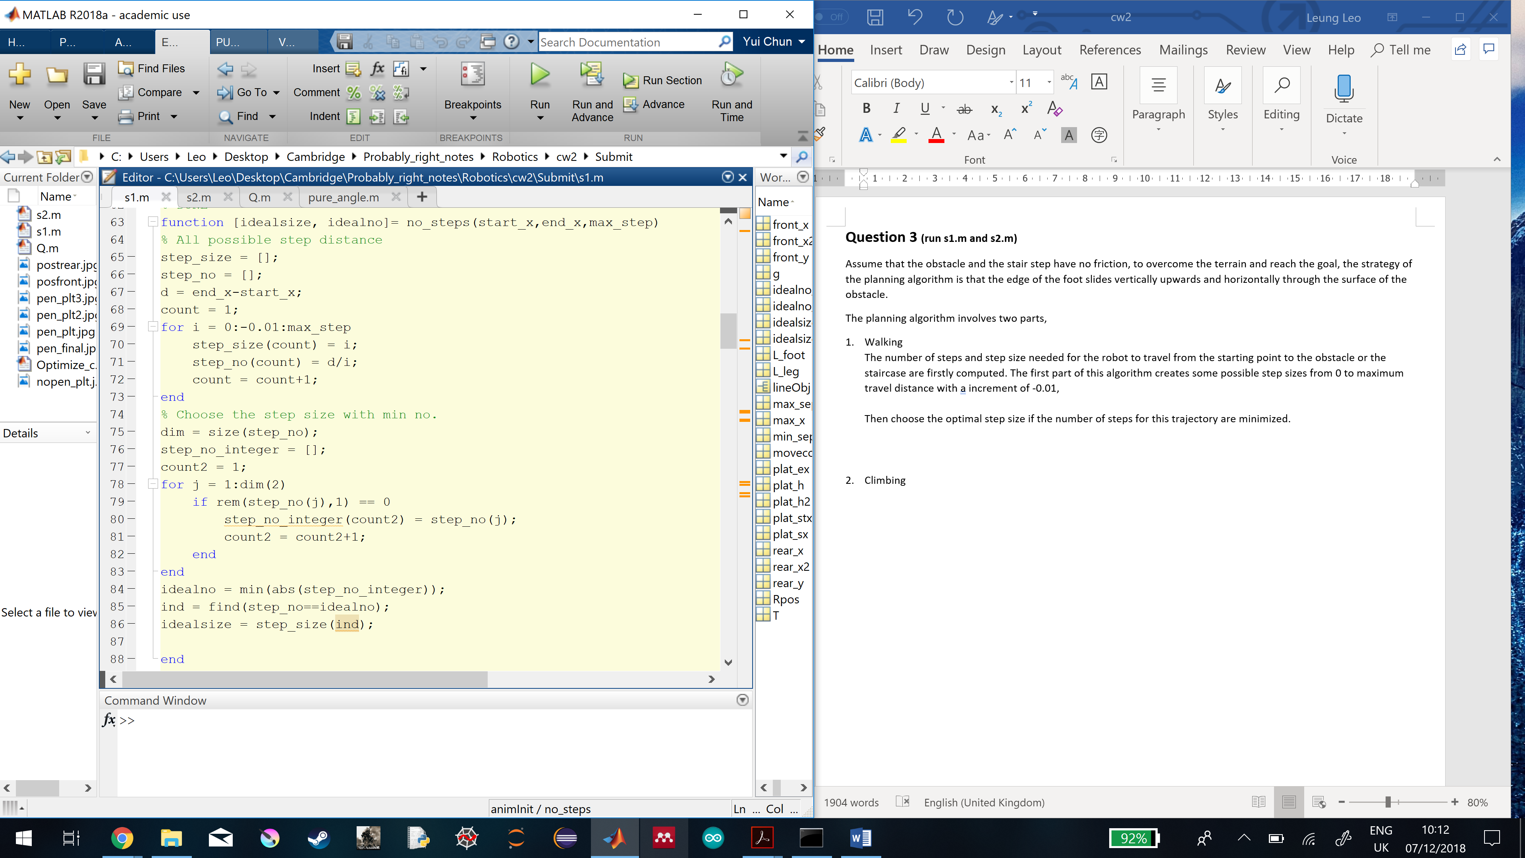

Then choose the optimal step size which can satisfy the condition that the number of steps for this trajectory are minimized.

To avoid the repetitive calculation of step size needed, the step size is still being used after the robot climbs over the obstacle or the staircase.

To generate the full joint angles trajectory, all the parameters calculated above are put into the function that can transform the step size and the number of steps into front (joint 0) and rear (joint 4) feet step locations, the moving foot index and three joint angles. This information is then stored into the matrix.

So, the following matrix is in the format of,

Table shows how the information matrix about the robot locomotion is formatted.

|  |  |
| --- | --- |
| 1 | Front foot (joint 0) x-location |
| 2 | Rear foot (joint 4) x-location |
| 3 | Front foot (joint 0) y-location |
| 4 | Rear foot (joint 4) y-location |
| 5 | Moving foot index (indicates which foot is moving) |
| 6 | Joint angle 1 |
| 7 | Joint angle 2 |
| 8 | Joint angle 3 |

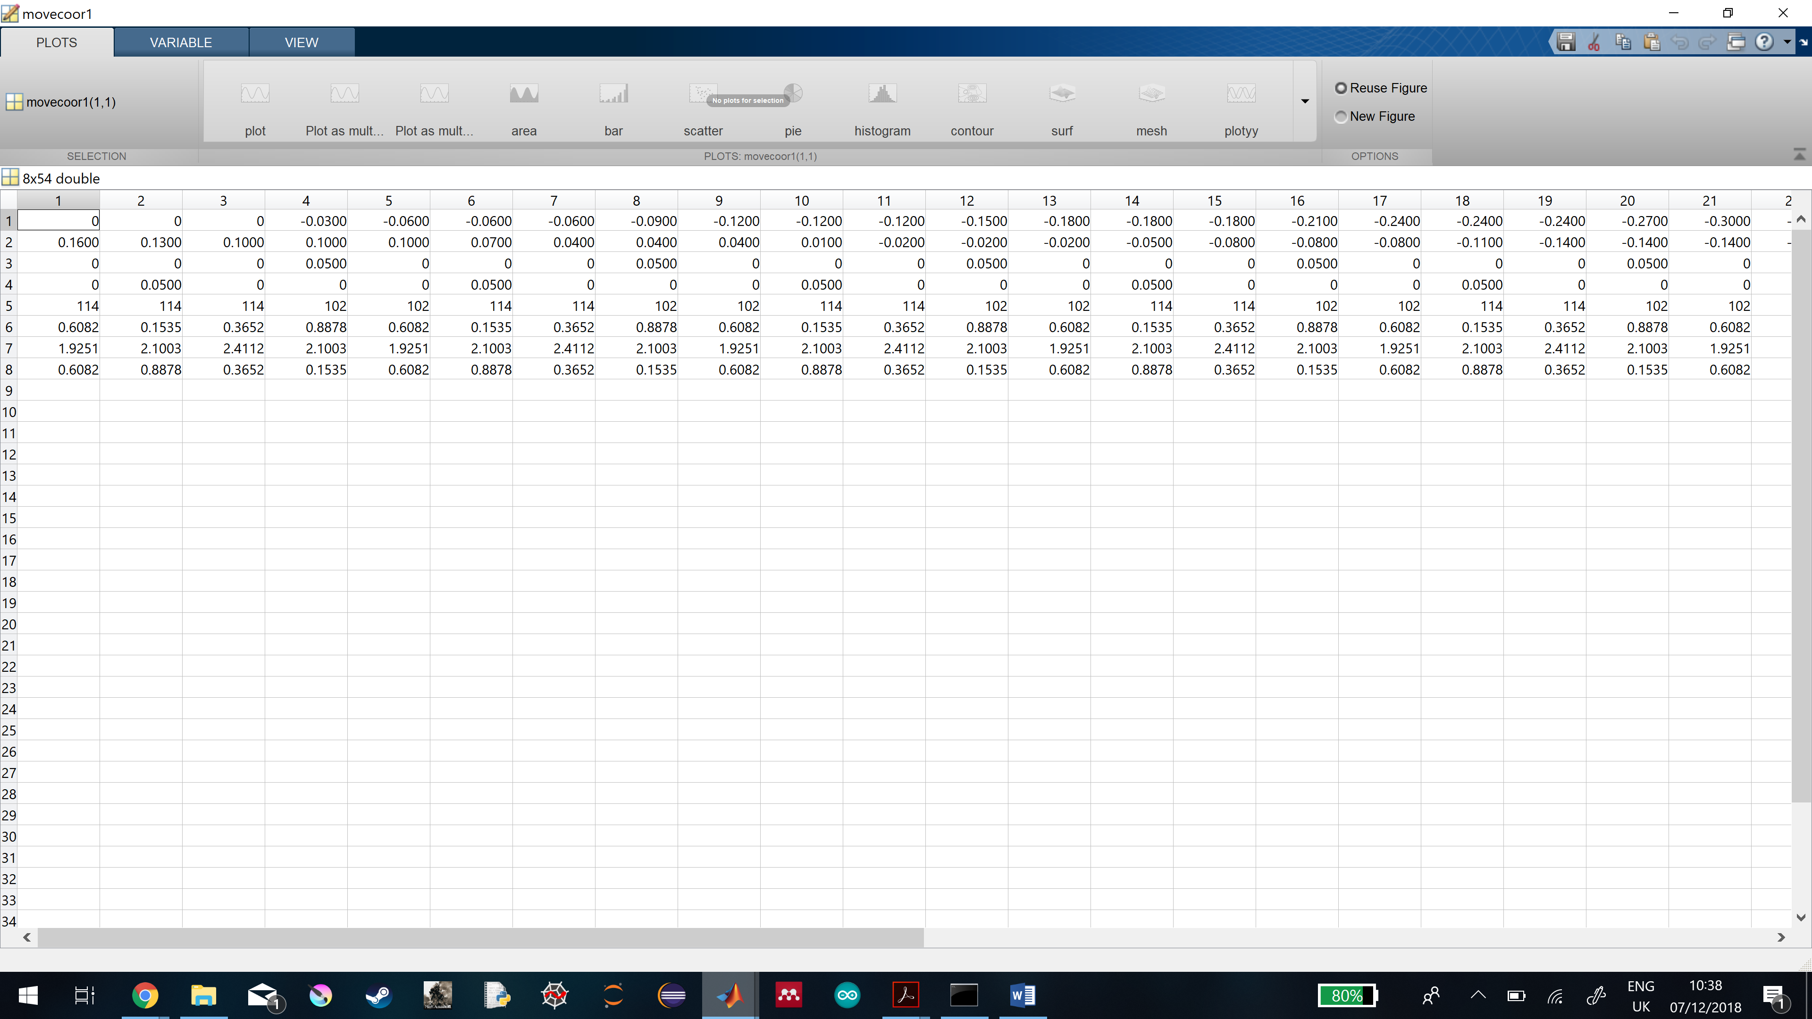

1. Climbing

1

2

3

4

Barrier

Barrier

Barrier

Barrier

Figure : Strategy applied to climb any obstacle.

Once the robot has reached the obstacle or the staircase, the climbing part of the algorithm is activated. The foot which is close to the barrier is raised vertically upwards to the height of the barrier, and then moving forwards horizontally until the whole foot is fit on the barrier. Once the first foot has landed properly, the next foot is also raised vertically upwards to the height of the barrier, and then moving forwards horizontally until the whole robot is standing upon the barrier.

With this climbing part, it allows the robot to overcome any barrier.

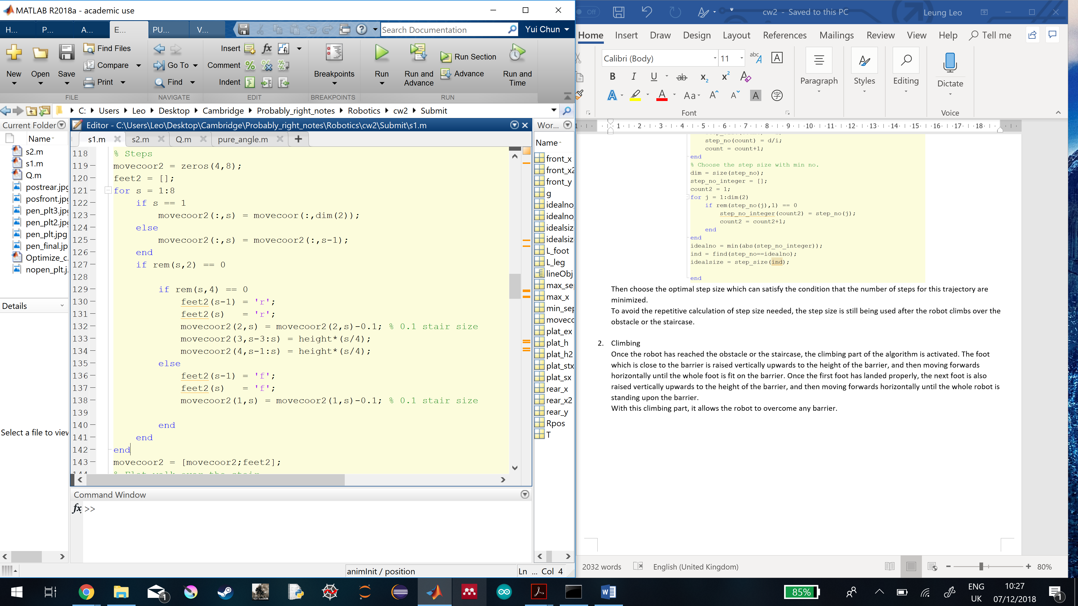

**Question 4 (run Q.m)**

A breadth-first search (BFS) Q-learning algorithm is developed in this question to allow the simulated robot to learn locomotion of its foot.

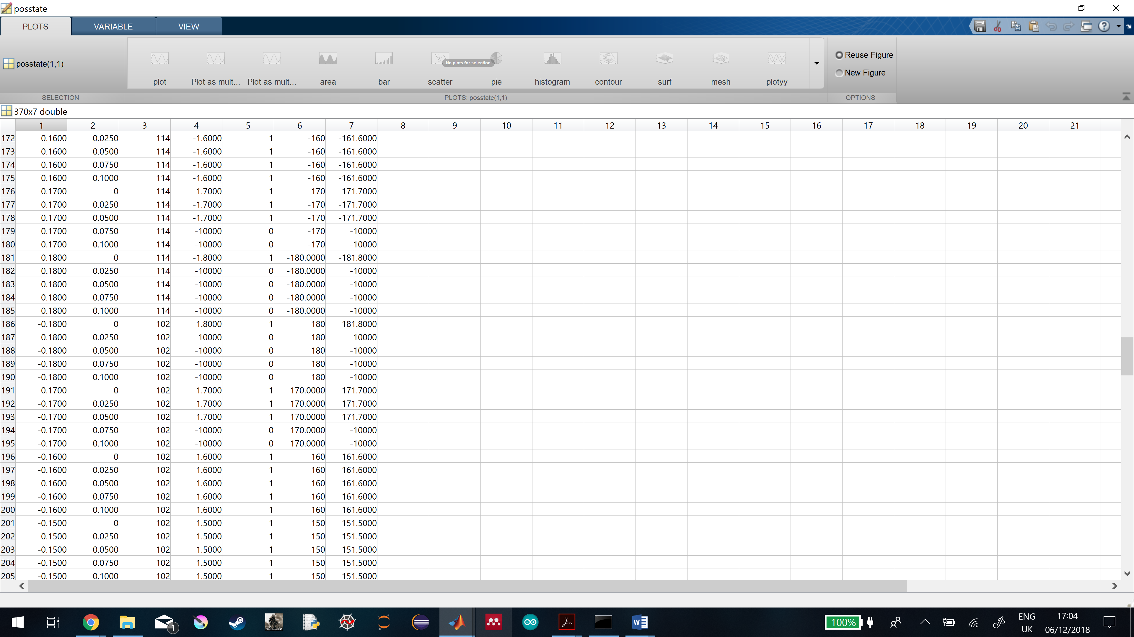

Table shows how the matrix stores the information about all possible states and their rewards.

|  |  |  |  |  |  |  |
| --- | --- | --- | --- | --- | --- | --- |
| 1 | 2 | 3 | 4 | 5 | 6 | 7 |
| All possible x-states | All possible y-states | Rear leg ‘r’ denoted by ASCII (114) | Reward from the pose | Physicsally possible due to the pose?  (Boolean) | Reward from the location | Sum of all reward (pose+location) |
| All possible x-states | All possible y-states | Front leg ‘f’ denoted by ASCII (102) | Reward from the pose | Physically possible due to the pose?  (Boolean) | Reward from the location | Sum of all reward (pose+location) |

The matrix above is created to store all the useful information about the possible states for each decision state made by the robot, based on the following procedure

1. Setting up possible states for both feet (1st,2nd and 3rd column of the matrix)

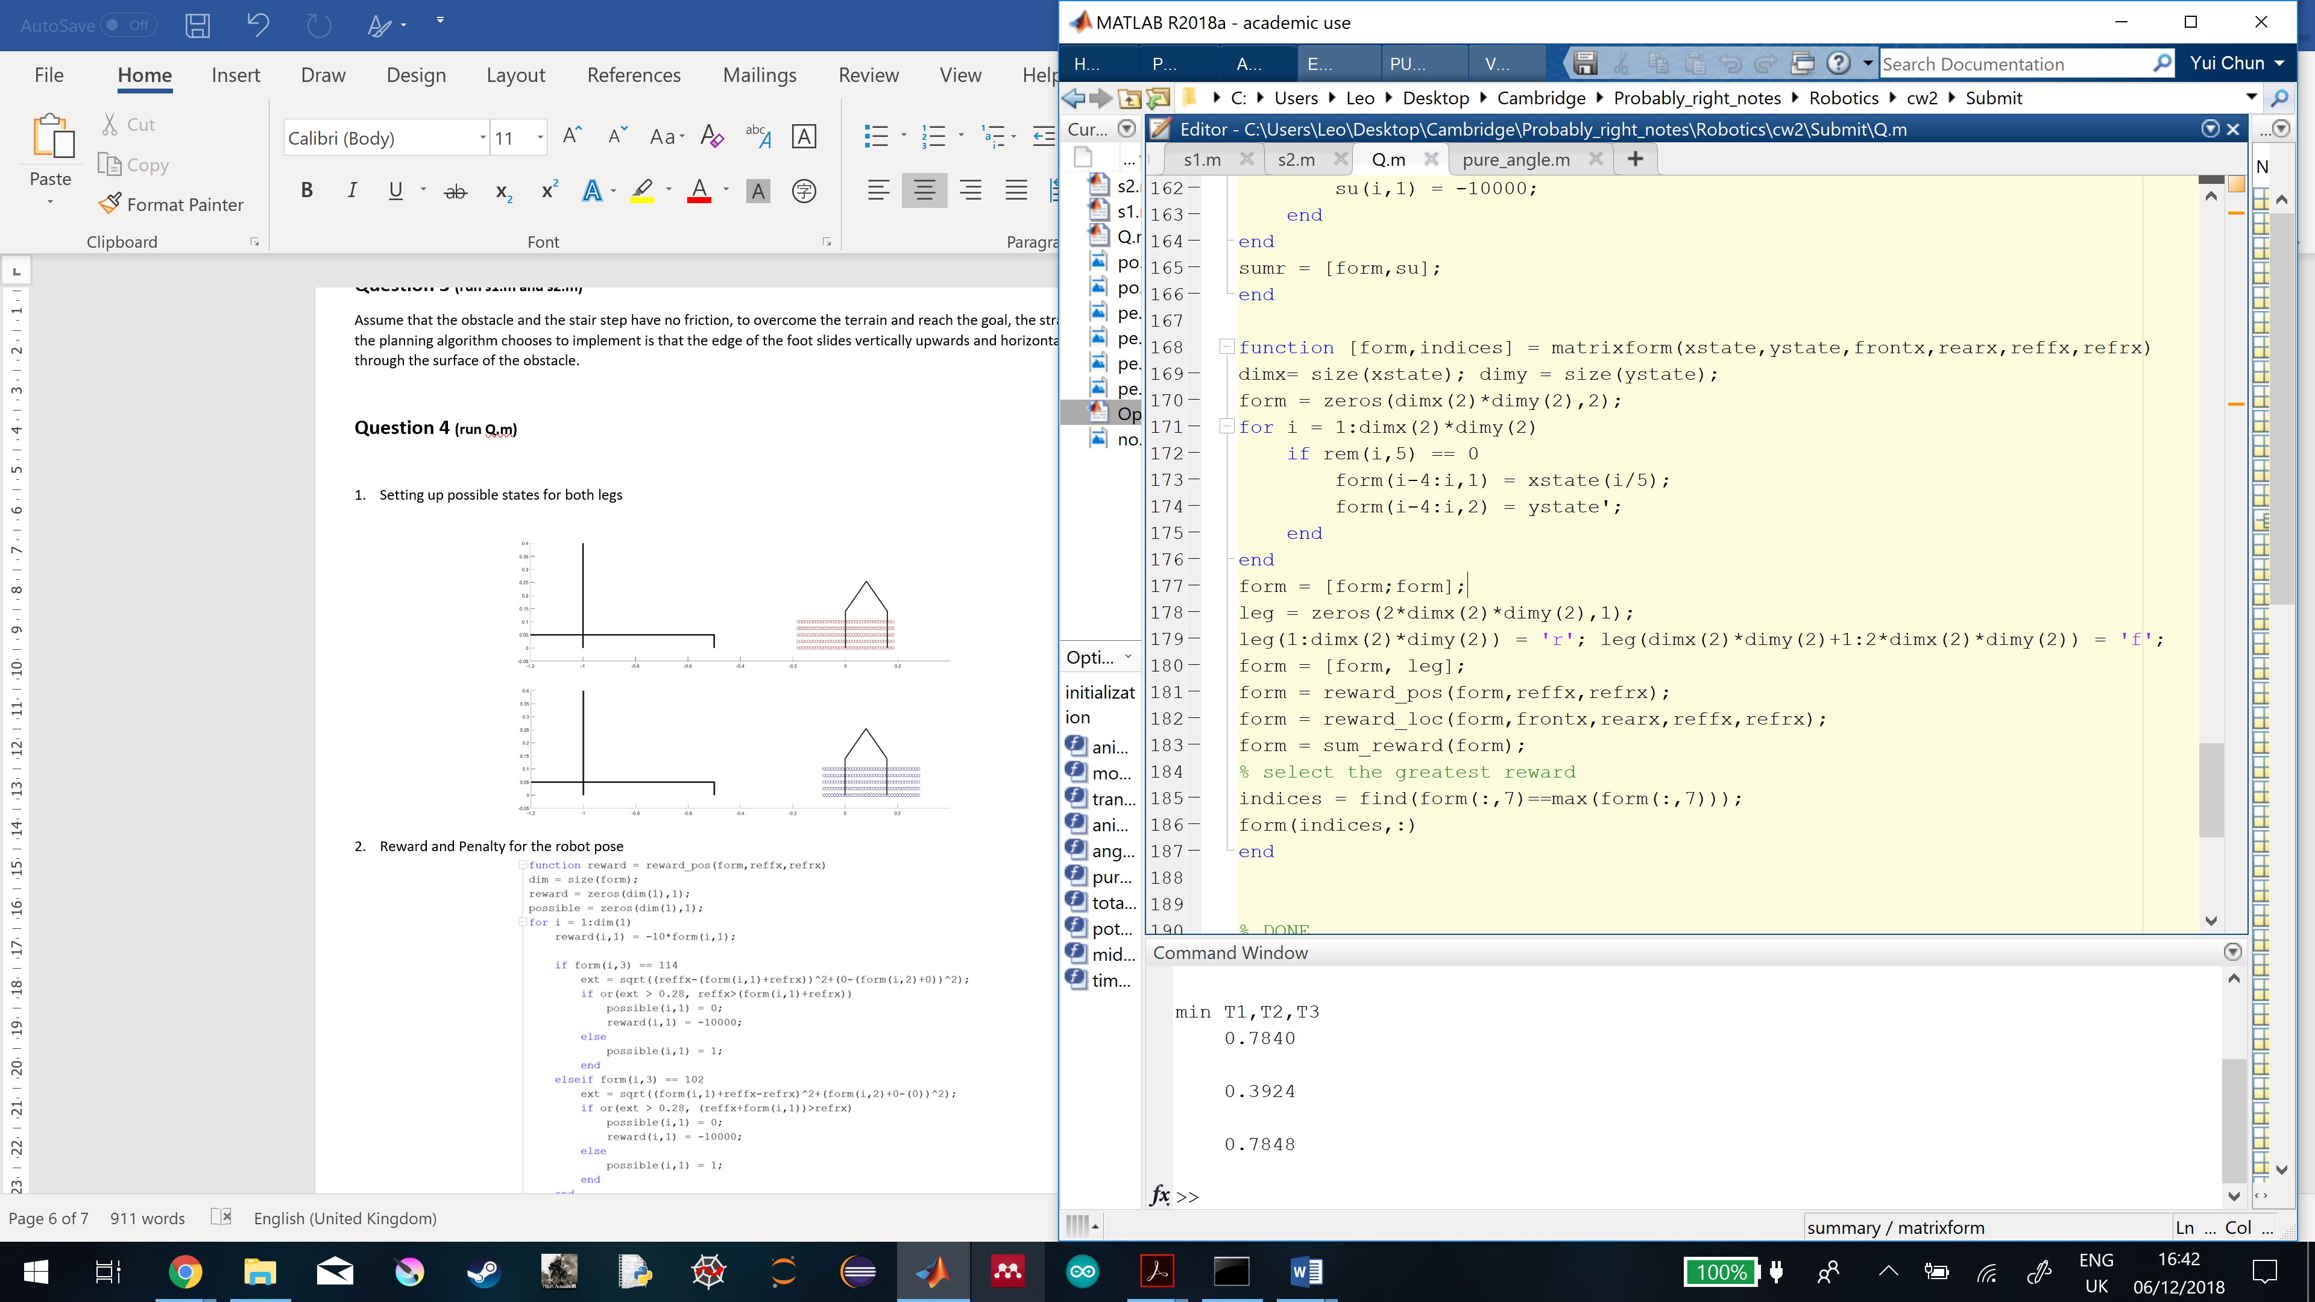

To make the task computationally possible, I have set up a finite number of choices for each dimension for each foot to choose from. The number of choices is also large enough to allow the robot to overcome any obstacle in a trial-and-error manner.

For the x-axis, the possible states range from -0.18 to 0.18m with a step of +0.01m so the number of x-states is 37. For the y-axis, the possible states range from 0 to 0.1m with a step of +0.025m so the number of y-states is 5. And for each x state value, 5 possible y states are available. So, a total number of states available for each leg is 37x5 = 185.

As the result, in Figure, each circle represents each possible state in the 2d space. The red circles denote the front feet states, and the blue ones denote the rear feet states.

To give both feet to have equal opportunities to move, all possible states for both feet are put into the 1st and 2nd columns of the same matrix. And to distinguish whether the possible states belong to front or rear foot, the 3rd column is encoded with the feet information using ASCII standard. Ideally, whether the robot moves its front or rear feet in that decision state depends on the final reward system.

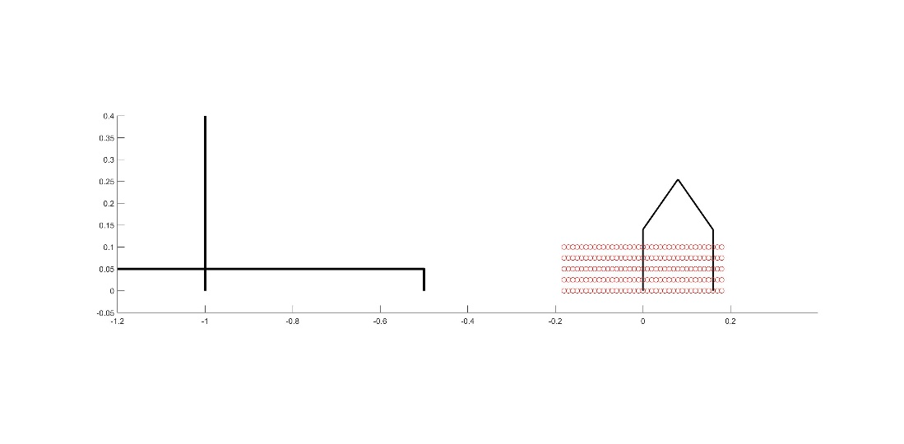

Figure

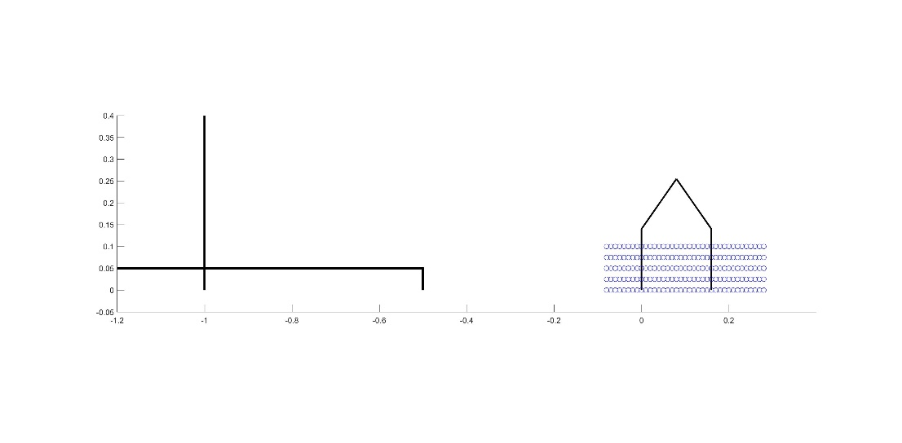

Figure

1. Reward and Penalty for the robot pose (4th and 5th column of the matrix)

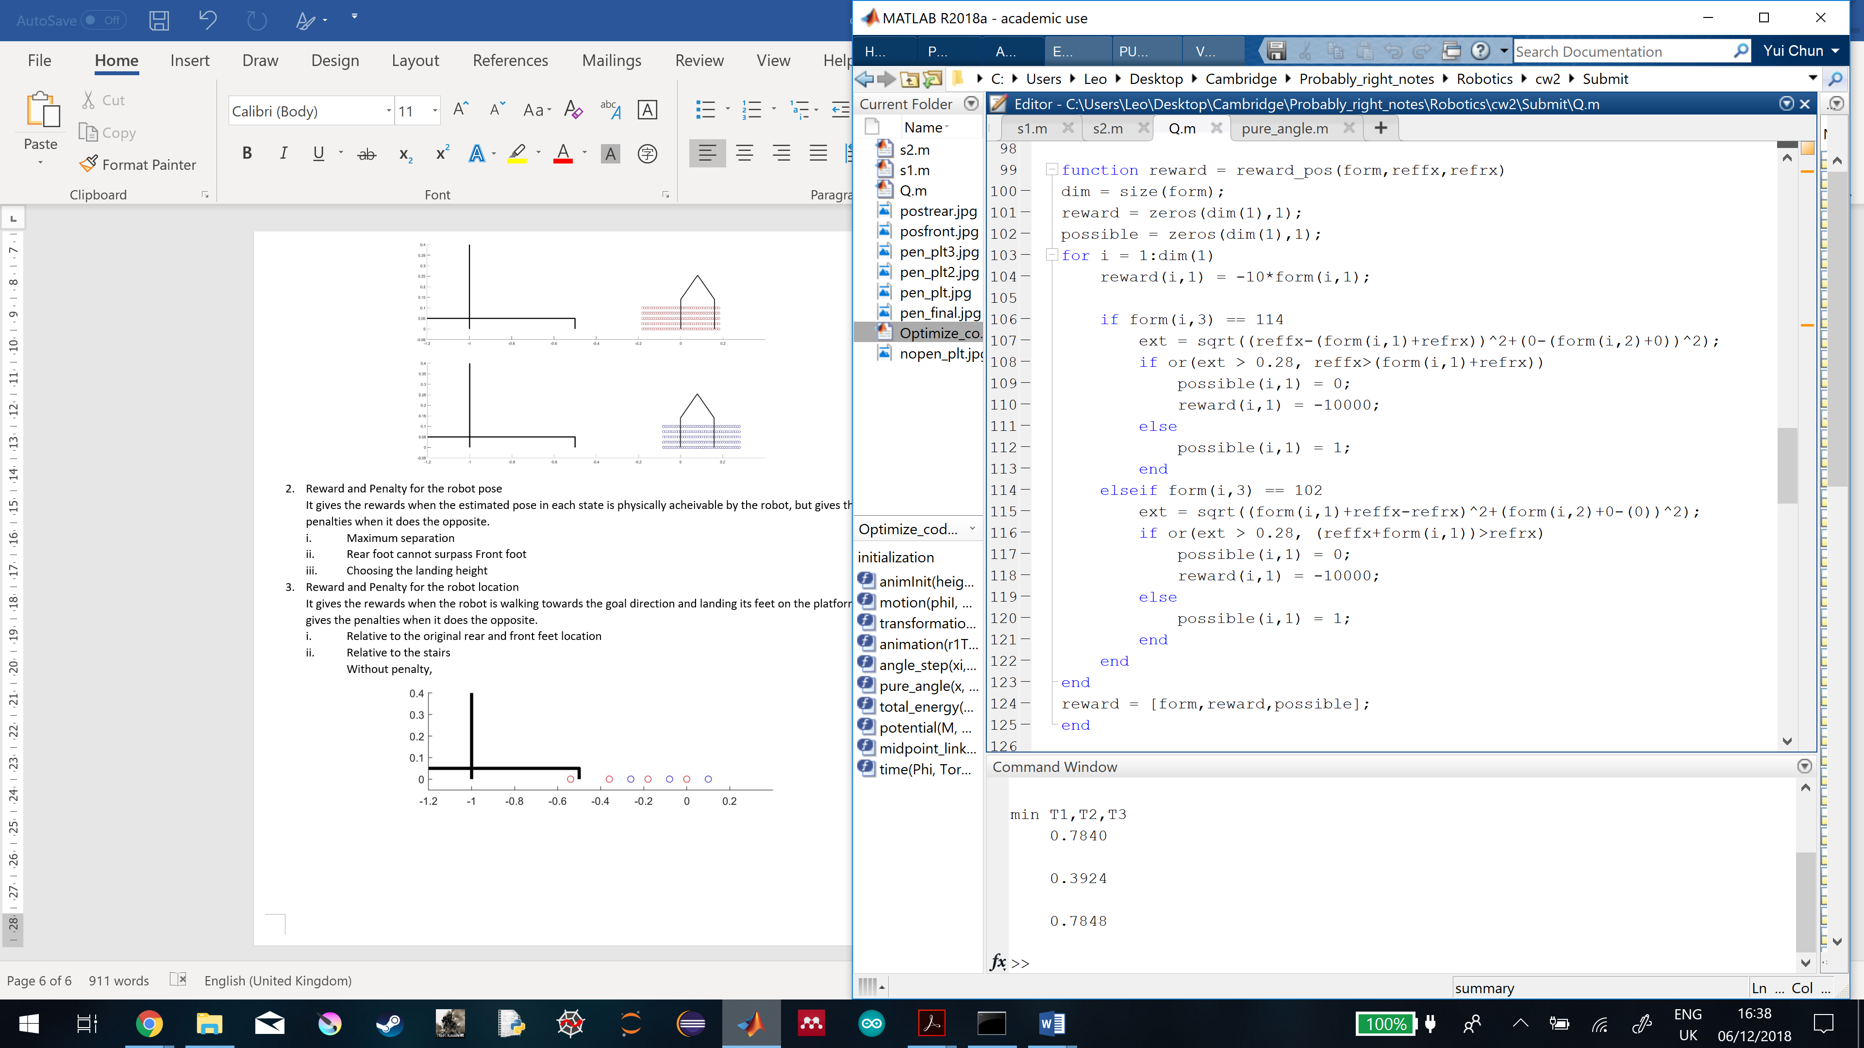

It gives the rewards when the estimated pose in each state is physically acheivable by the robot, but gives the penalties when it does the opposite.

1. Maximum separation

Assume that the sum of the joint angles is ${180}^{°}$ which allows the feet land perpedicularly on the ground, the maximum separation between the joints 0 and 4 is $0.28m$ which is the sum of $L_{2}$ and $L_{3}$.

The separation between the rear foot (joint 4) and the front foot (joint 0) is given by,

$$s=\sqrt{{\left(x_{front}-x_{rear}\right)}^{2}+{\left(y_{front}-y_{rear}\right)}^{2}}$$

, where $s$ the joints 0 and 4 separation, $x_{front}$ the joint 0’s x position, $x_{rear}$ the joint 4’s x position, $y_{front}$ the joint 0’s y position and $y_{rear}$ the joint 4’s position.

If $s > 0.28$, the following state will be penalized with $-10000$.

1. Rear foot cannot surpass Front foot

The condition $x_{front}≤x_{rear}$ is set. If $x_{front}>x_{rear}$, the following state will be penalized with $-10000$.

1. Reward for the pose approaching the goal direction

Since the terrain and the goal are set on the negative side of the x-axis, the reward is set to be 10 times the opposite sign of the x state position. For example, if the front foot chooses to move towards $-0.18m$ relative to its initial landing spot, the goal is positioned at $-1m$, the reward will be $1.8$.

The reward equation is given by,

$$R=-10\left(x_{state}\right)$$

, where $R$ the reward and $x_{state}$ the possible states along x-axis ($linspace\left(-0.18,0.18,37\right)$).

1. Reward and Penalty for the robot location (6th column of the matrix)

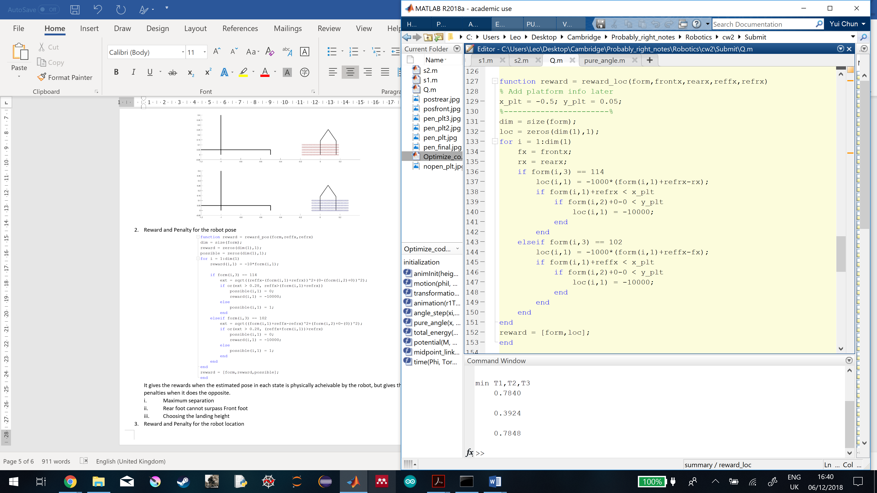

It gives the rewards when the robot is walking towards the goal direction and landing its feet on the platform, but gives the penalties when it does the opposite.

1. Relative to the original rear and front feet x location

Giving reward due to the motion towards the goal relative to the starting position allows the robot to figure out which direction it should go. And it is more important than the pose it choose to move, so the following reward is set,

$$R=-1000\left(x_{i}-x_{start,i}\right)$$

, where $R$ the reward, $x_{i}$ the current location of the foot $i$ which is the sum of $x_{state}$ and $x_{ref,i}$ the latest reference location of the foot $i$ and $x_{start,i}$ the starting x location of the foot $i$.

It is important to note that the distance travelled along y-axis is not considered since our goal is to reach $x = -1m$. Later, the obstacle penalty will be introduced so that the robot will learn to lift the feet.

1. Relative to the stairs

Once one of the feet is stepped into the region where the terrain is positioned, the stair penalty is activated when the foot is below a certain height.

When the penalty is not set, the front leg chooses to land below the terrain.

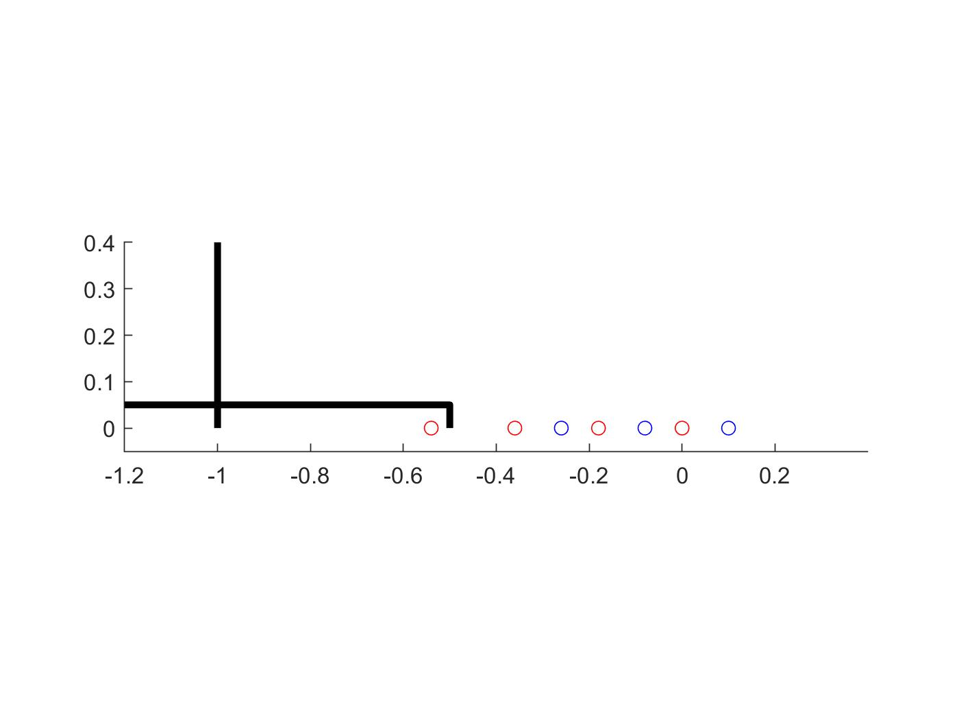

Figure

When the penalty is set, the front foot can land on the terrain. Also, due to the pose penalty, the robot chooses to retreat its front foot to make the landing pose on the terrain physically achievable.

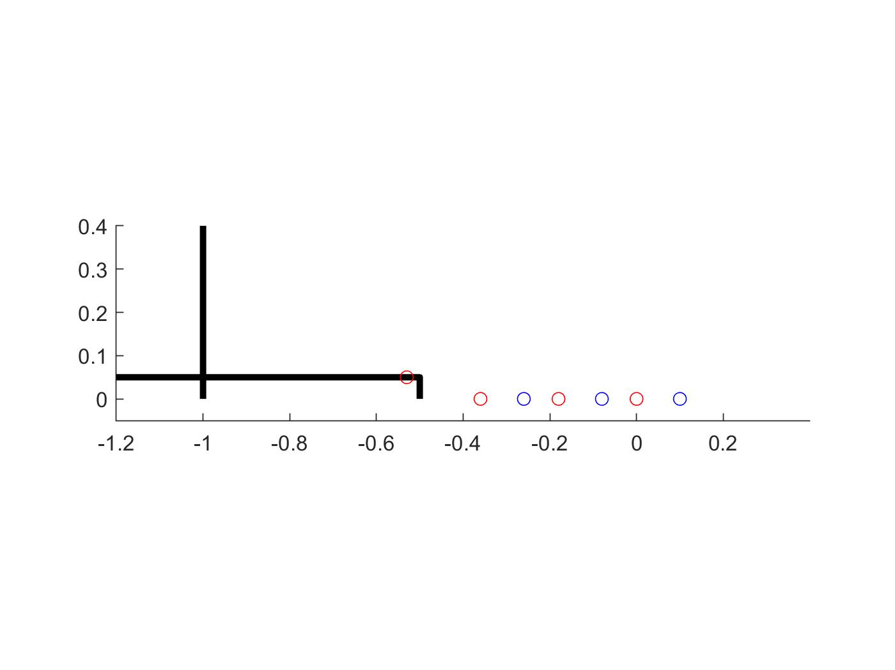

Figure

1. Sum all the rewards and penalties for each state (7th column of the matrix)

The reward values from the 4th and 6th columns from the given state are summed up to compute the overall reward for that given state.

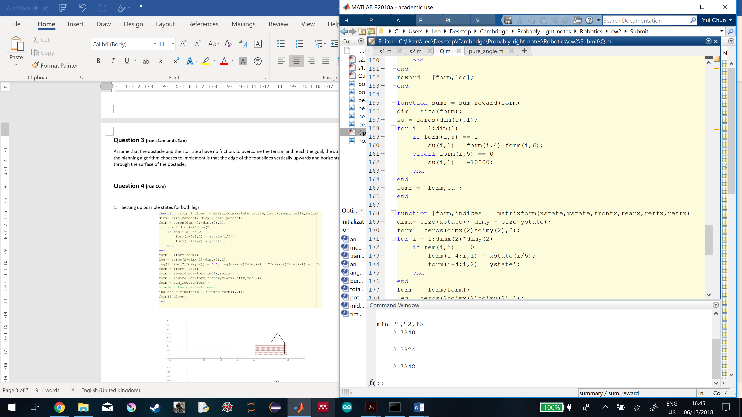

1. Decision making based on the total reward

The row indices with the maximum overall reward are obtained.

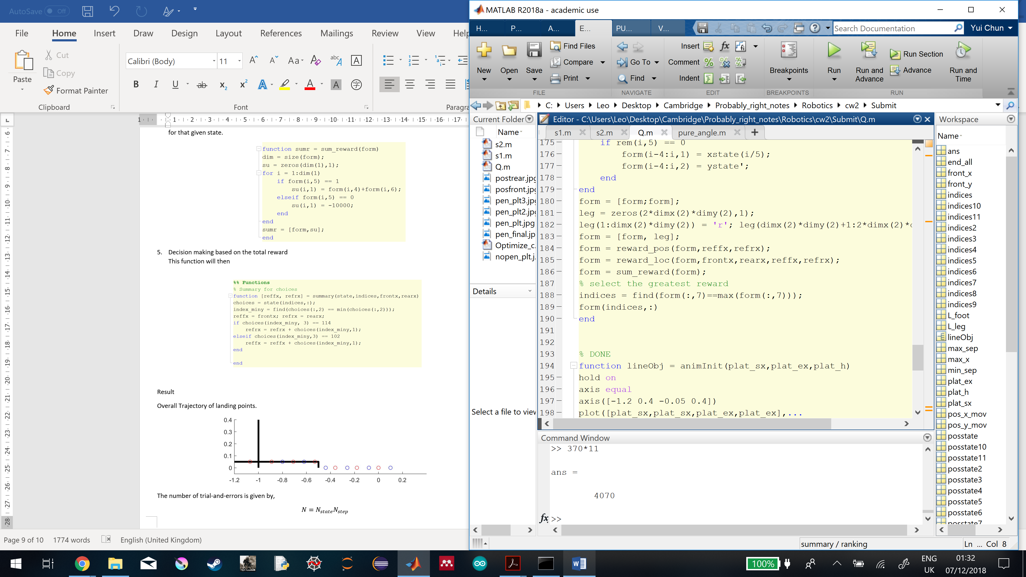

Sometimes there are more than one states having the maximum reward, especially when the reward system is based on the x-axis trajectory, but since this Q-learning algorithm is used to predict the landing location of the feet only, the state with maximum reward and minimum height is chosen as the final decision.

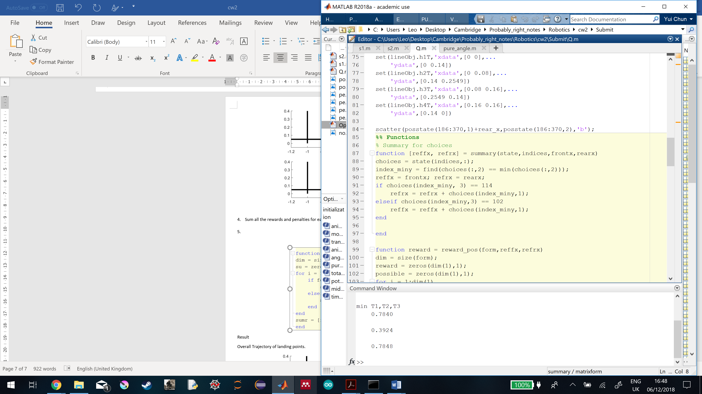

**Result**

Overall Trajectory of landing points.

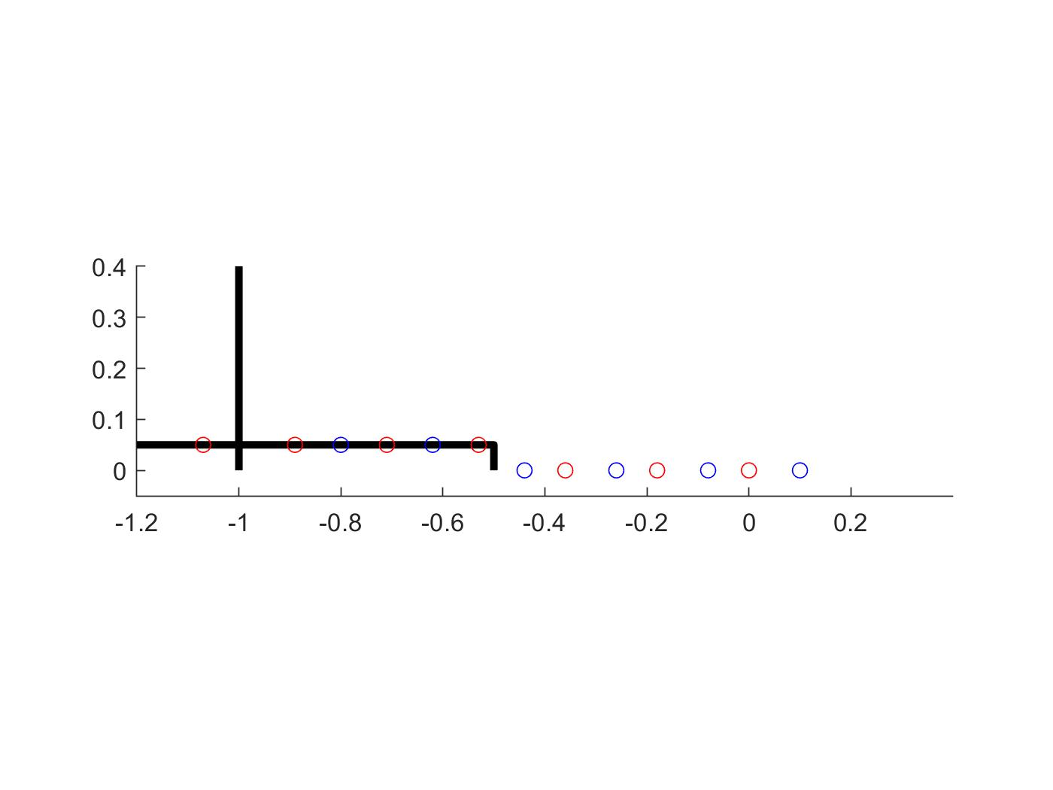

Figure

The number of trial-and-errors is given by,

$$N=N_{state}N_{step}$$

, where $N$ the number of trial-and-errors, $N_{state}$ the number of all possible states and $N_{step}$ the number of steps made.

So, the number of trial-and-errors is $370\left(11\right)=4070$.